North West Regional Women’s Committee (NWRWC)

Annual Report 2016

The NWRWC have worked to their plan as below and have welcomed a number of new committee members who have either been elected to or are currently covering the role of Women’s Officer for their Branches. The committee had an interesting and productive year with members attending conferences and events outside the CWU to broaden their knowledge

- To provide support and advice for Women’s Officers & NW branches in recruiting and developing women activists

The three Toolkits are available on the CWU northwest website to anyone as required. Paper copies are also available on request. It is intended to update the toolkit as soon as possible and re-distribute it across the Region.
A working party has been put together to organise workplace visits/events at Royal Mail sites in the Warrington area and we are hoping to get our first women’s workplace committee up & running this year at Manchester Mail Centre.

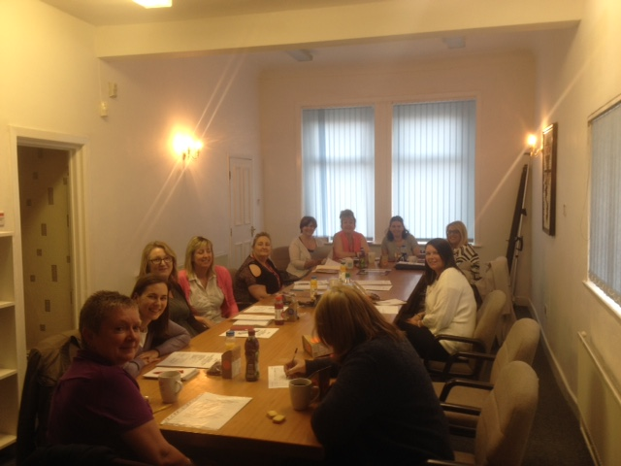

- Interact with the NW TUC and other unions regarding women’s issues

I have been re-elected as one of the Co-Chairs of the NW Women’s TUC Committee again and will hold the position through to 2018.
A motion has been put forward to the NWTUC Conference regarding harassment of women in the workplace. Women from other unions took part in our Women of Today event 2016 and will be supporting us again in 2017.

- Organise & run workplace visits and events for NWRWC and members

We had another highly successful ‘Women of Today’ event in January 2016 with Guests such as Kelly Morgan, the British Champion boxer and Soledad. Our next ‘Women of Today’ event in January 2017 is planned for Thursday 26th January at the Mechanics Centre with Francesca Martinez headlining (now passed). The information was circulated via a Letter to Branches (LTB746/16) and directly to all Women’s Officers. A report will be given verbally today at the AGM. My thanks go to all the committee but especially to Gail Nicholas, the committee Vice Chair during 2016 and the Northern and National Financial Services Branch for their invaluable help and support with the 2016 event.

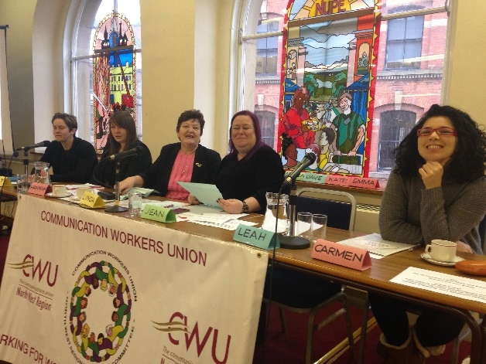

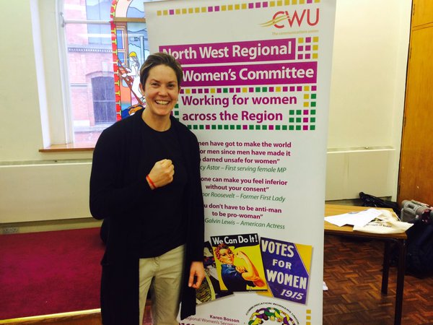

- Highlight the issues of women by utilising support networks and services available to women in our region

We continue to signpost our members to the support services available to them both inside the CWU and externally. We created a strong link with Kathy Devlin from Beacon Counselling Trust during 2016 and she will be one of our guest speakers at our 2017 Women of Today Event. A Working Party has been put together to create a campaign during 2017 to raise awareness of issues related to gambling.

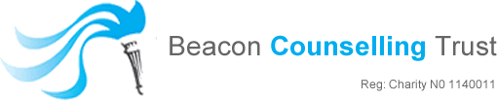

I was a guest speaker at the Working Class Movement Library’s International Women’s Day event on the 5th March and highlighted issues around the Trade Union Bill. We also held our April committee meeting at the WCML and followed this with a tour of the library.
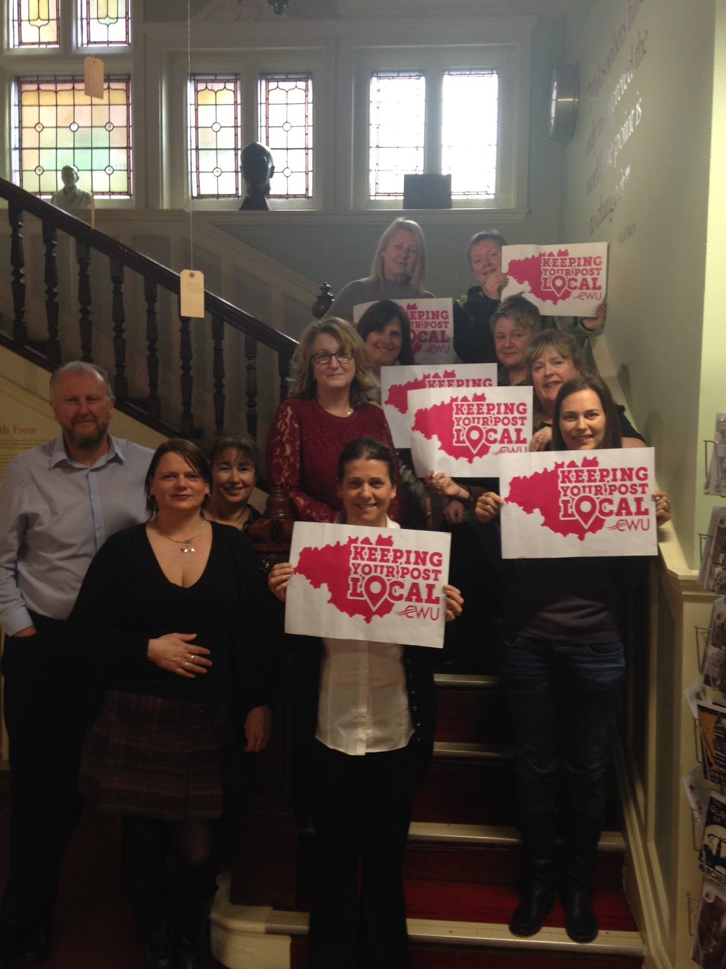

- Share knowledge & experience with other RWCs

We attended the joint WAC/RWC meetings throughout the year. In May we went to Cardiff and South East Wales Amal branch hosted our meeting.
Women from across the CWU Regions will be attending the 2017 Women of Today event. It is unfortunate that most of cannot attend the Eastern Region’s first Women’s Event ion Peterborough on 25th January as it is the day before ours. A message wishing them good luck and apologising for not being able to be with them has been sent to the Eastern RWC Secretary and Chair on behalf of our committee.

- Update Women’s section of Regional website at least twice a year

This will be updated as soon as possible

- Support CWU National and Regional campaigns e.g. Agency Workers, zero-hours contracts, living wage

CWU women continue to be actively involved with all the campaigns held regionally and nationally.

- Raise political awareness with women members in the NW and encourage women activists to become more involved in decisions affecting public life.

The Women of Today event held in January this year gave members and activists the opportunity to meet a number of female MPs, local councillors and women who are politically active. Committee members also attended the NW Labour Party Conference and spoke to our NW MEPs.

- Encourage branches to set up an informal Women’s Group or committee to help branches with issues primarily affecting women.

This is ongoing business as usual. We are hoping to have our first set up at Manchester Mail Centre this year.

- Share expertise and knowledge with CWU branches and Regional Committees.

The committee continue to support other NW committees and branches as often as they can.

- Encourage communication regarding industrial issues

Branch reports given at each NWRWC now include more discussion regarding industrial issues and committee members are encouraged to raise motions locally, regionally and nationally.
We held a very successful motion writing workshop during one of our meetings so already have ideas for next year’s conferences. Committee members are currently providing their knowledge to help RM improve their uniforms for women.

The committee are looking forward to 2017; encouraging each other, arranging site visits and events as well as giving our support for campaigns and initiatives affecting women inside the CWU and beyond across our region.

Our top 3 priorities from the 2017 Campaign Plan will be:-

- Organise and run workplace visits and events for NWRWC and members
- Support CWU National and Regional campaigns e.g. People’s Post, Post Office Ltd, Agency Workers, Pay before Assignment (PBA) contracts, zero-hours contracts, living wage and the Trade Union Bill.
- Encourage all Women’s Officers to submit motions to CWU National, Industrial and Equality Conferences

Karen Bosson
NWRWC Secretary
karen@cwu-mancom.org
07894 423892

North West Regional Women’s Committee (NWRWC)

Campaign plan 2017

- To provide support and advice for Women’s Officers and Northwest branches in recruiting and developing women activists

- Interact with the NW TUC and other unions regarding women’s issues

- Organise and run workplace visits and events for NWRWC and members

- Highlight the issues of women by utilising support networks and services available to women in our region

- Share knowledge & experience with other RWCs

- Update Women’s section of Regional website

- Support CWU National and Regional campaigns e.g. People’s Post, Post Office Ltd, Agency Workers, Pay before Assignment (PBA) contracts, zero-hours contracts, living wage and the Trade Union Bill.

- Raise political awareness with women members in the NW and encourage women activists to become more involved in decisions affecting public life.

- Share expertise and knowledge with CWU branches and Regional Committees.

- Encourage communication regarding industrial issues

- Encourage all Women’s Officers to submit motions to CWU National, Industrial and Equality Conferences

The plan is ambitious but achievable, sets out our priorities for the future and will be amended as needed

